CHONG BEE AND MAY VANG
LIVING LEGACY SCHOLARSHIP

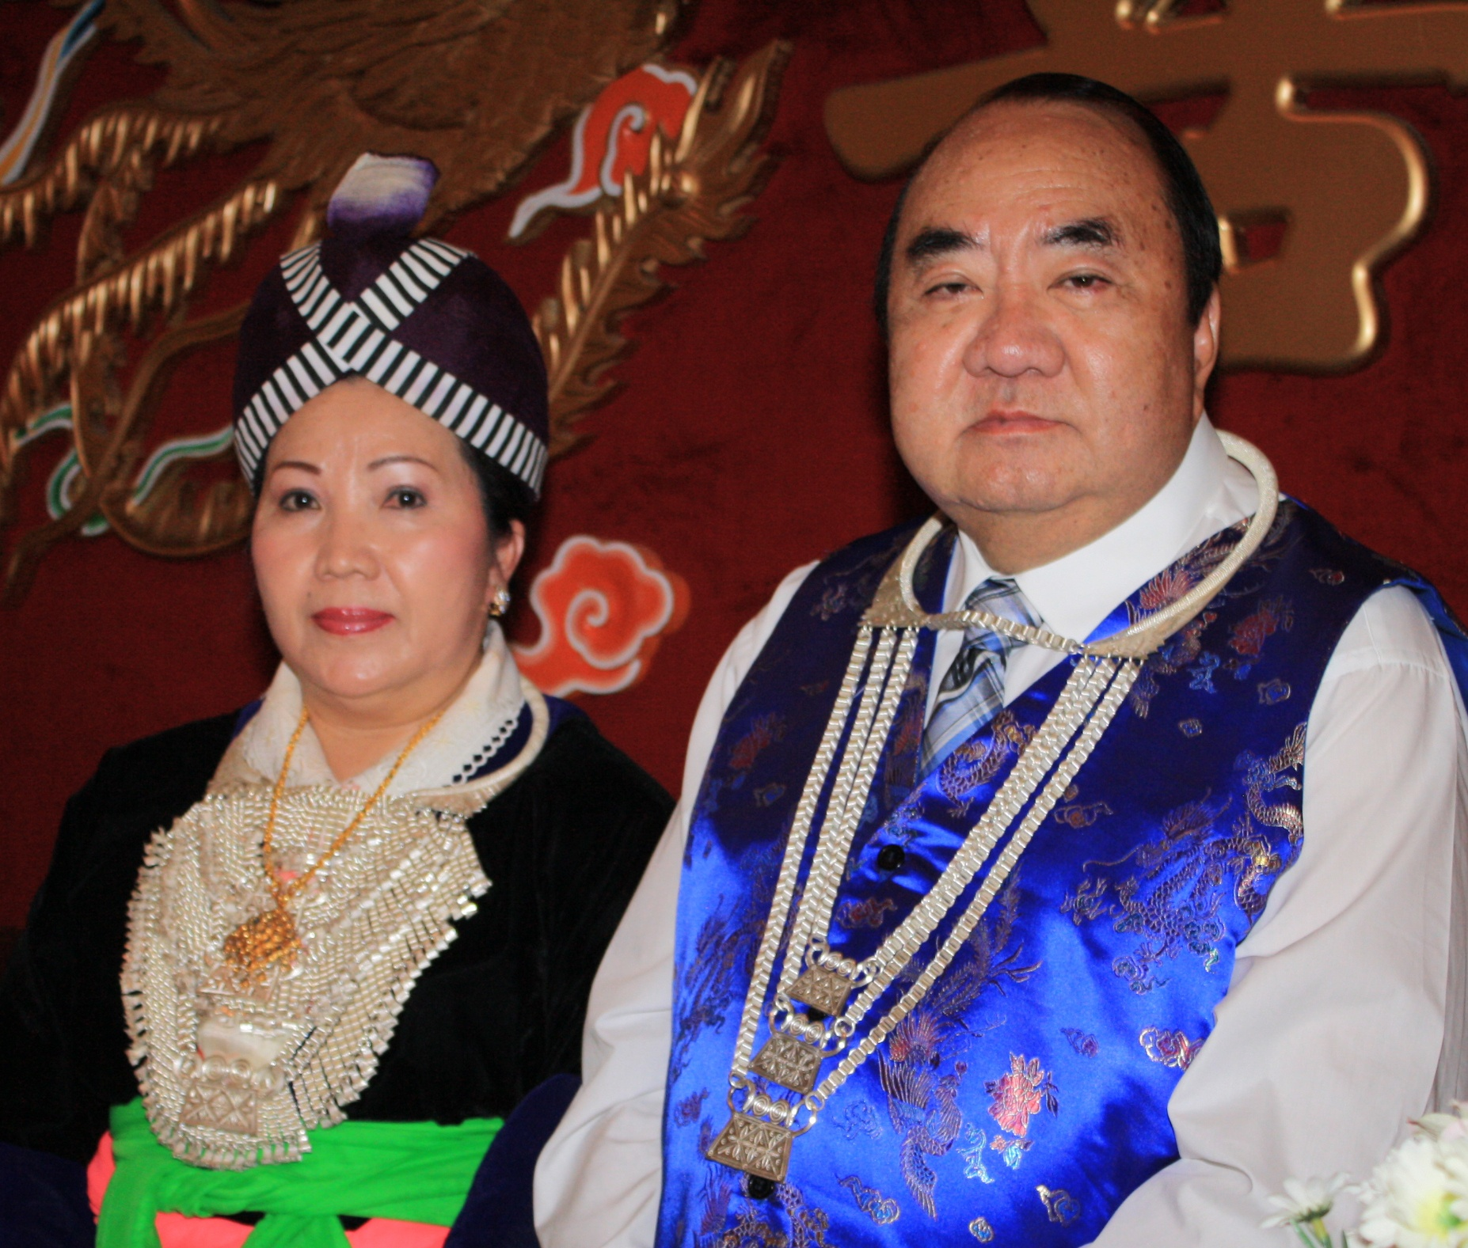

PRESENTED BY
THE HMONG AMERICAN EDUCATION FUND
www.thehaef.org

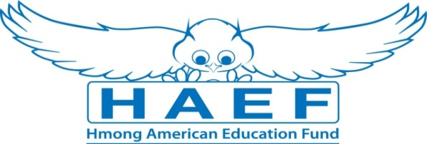

CHONG BEE VANG AND MAY VANG

LIVING LEGACY SCHOLARSHIP

Chong Bee and May Vang immigrated to America in 1975 with little next to nothing. Being one of the first waves of Hmong Immigrants to Pennsylvania and then to Nebraska where their church sponsors provided them with instructors to teach them what was similar to ESL classes. This was their first introduction to education in the States, but they both are no stranger to education, Chong Bee and May have always attended school in Laos and believed in higher education. After completing the ESL classes, they were able to find work. Soon after this, more relatives were arriving to Nebraska, but the ESL classes were no longer available. Realizing that without education for their relatives, they will not be able to provide for their families, Chong Bee made the decision to relocate all the family to Minnesota.
Once settled in Minnesota Chong Bee went on to further his education. Enrolled in St. Paul Technical College, Chong Bee received his high school diploma. Continuing to Minneapolis Community College, he received his Associates of Science in 1984. Wanting to set a solid educational foundation for his growing family of 8 kids, he enrolled to St. Cloud State University and received his Bachelor of Science in Social Work in 1988. Chong Bee became involved working with Lao Family of Minnesota, Inc for 2 years before attending University of Minnesota to obtain his Masters of Social Work in 1992. Chong Bee wanted to help his Hmong people in the community. He took the Presidential seat of Lao Family from 1992-1997 and continued his social work with A Community Outreach Program, where he worked with troubled youth living in project homes from 1992-2000.
May has always accelerated in school while living in Laos. May started enrolled in a 6 month English program once settled in Minnesota. She continued at Central High School, where she received her diploma. May went on to vocational school to earn her Banking and Finance certificate. She soon took a job counselor position with Hmong Women Association. After a few years of working, Chong Bee and May decided to start their own business. With Chong Bee being the face, and May being the driving force behind, they both have been very successful owners of multiple business entities. All of this would not have come about without their strong background in school.

(Photo provided by the children of Mr. and Mrs Chong Bee Vang)
Instructions for the Chong Bee and May Vang Living Legacy Scholarship
This scholarship is presented by the Hmong American Education Fund. The scholarship seeks to financially support two dedicated Hmong-American students (one male, one female) in the pursuit of their higher educational goals. The successful applicant will be awarded up to $2,500 each to the choice of their college or university. The scholarship will be dispersed over four years. Download this application packet and fill out the form below. All application materials are due by April 15. Late applications and materials will not be considered. Any hand written application will be disqualified. All application materials must be emailed to: hmongeducationfund@gmail.com. You will be notified of your application status via email by June 1.
Scholarship Selection Criteria and Eligibility
- A U.S. citizen or legal resident alien
- Any state resident
- Any person of Hmong descent
- A high school senior or has earned a high school diploma or GED
- Has been accepted fulltime to a public /private accredited 4-year college/university
- Has a minimum GPA of 3.0 in a 4.0 scale system
- Applicants who had lost one or both parents
Scholarship Application Packet, Checklist
- A completed application
- Essay (1500 words or less)
- Copy of unofficial transcript
- One letter of recommendation
- All required application documents should be sent in PDF format via email to hmongeducationfund@gmail.com
A Successful applicant must demonstrate the following
- Pursue an education to better themself and others
- A commitment to excellent academic achievement
- A show of strong leadership qualities
- A commitment to helping your community
- Demonstrated financial needs, or need based on hardships
Essay: In one essay, 1500 words or less, please answer the following questions
- Tell us about your commitment to education
- Tell us how losing a parent or both parents have impacted you
- Tell us some of the things you have done to help your community outside of school
Additional Requirements
- If the recipient is from Minnesota, he/she is expected to attend the Scholarship Awards Banquet on the first Saturday of August.
- If recipient is not from Minnesota, the donor of this scholarship will cover airfare cost for the recipient to attend the Scholarship Awards Banquet
- If selected, recipients are expected to submit the documents requested for the Scholarship Awards Banquet (ex. photo, bio, thank you letter to donors)
Successful applicants are encouraged to attend two general academic coaching and mentoring sessions with HAEF. These sessions can be done via phone, E-mail or face to face.
( If you have any questions, please email: scholarships@thehaef.org )

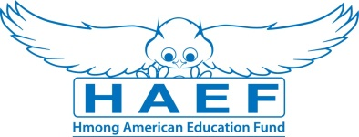
Chong Bee and May Vang Scholarship Application
(Type responses below & email back to hmongeducationfund@gmail.com along with all other required documents in PDF)
Last Name: | First Name: |  | Middle:
Home Phone: | Cell Phone: |  | E-Mail:
Gender:  Female Male | Date of Birth (mm/dd/yyyy): |  | Race/Ethnicity:
Current Address:

City: | State: |  | Zip Code:
Permanent Address (if different from above):

City: | State: |  | Zip Code:
Check one of the following:  U.S Citizen  Legal Alien Resident of U.S.  None | Are you a first generation student?  Yes  No |  | Marital Status:  Single  Married  Divorced  Widowed
Number of parent(s): | Family size: |  | Number of dependents (if applicable):
Are you currently in high school or pursuing your GED?
Yes
No
Name of your current School: |  |  | Current GPA:
School Address:

Name of College/University you have been accepted to and/or will be attending:

Major/Program:

Degree you are seeking: Associate BA/BS Masters PhD/Doctorate Other:

What year of schooling are you in: First Year Sophomore Junior Senior

Will you be a Fulltime Student: Yes No
Have you been awarded other scholarships or financial assistance? (If yes, please list them):

Print Name: |  | Signature: |  | Date:
Disclaimer: By signing this application I understand that the information provided is true to the best of my knowledge. HAEF reserve the right to verify information submitted on the successful candidate’s application. In addition, the views and opinions expressed by individuals and/or businesses featured in our scholarships do not necessary represent the views of the Hmong American Education Fund.

