NONG KHAI JUNIOR VANG
THE NONG KHAI JUNIOR VANG LEGACY MEMORIAL SCHOLARSHIP FUND
APPLICATION PACKET
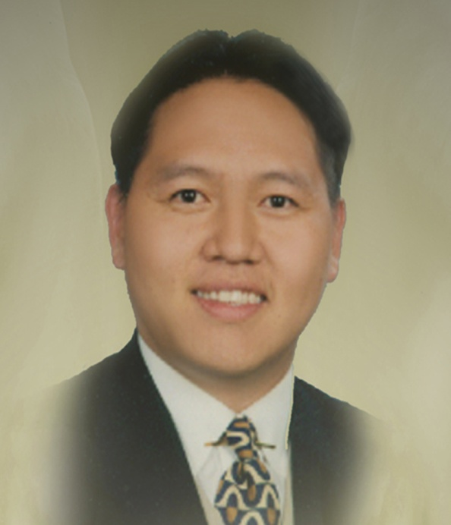

July 4th, 1975 – October 24th, 2006

PRESENTED BY
THE HMONG AMERICAN EDUCATION FUND
www.thehaef.org
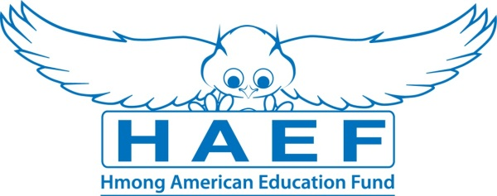

This scholarship was made possible and donated by Chue T. Vang & Joy Thao in loving memory of Nong Khai Junior Vang.

Nong Khai Junior Vang was the younger brother of the President/CEO and Founder of HAEF, Chue T. Vang. Khai was born on July 4th, 1975 in the Nong Khai Refugee Camp in Thailand to Neng Chue Vang and Mai Yia Xiong. Khai was only four years old when the family resettled in Omaha NE, in 1979. Then in 1981, Khai and his family moved to Oshkosh, Wisconsin where Khai grew up. He attended Webster Stanley Elementary and Middle Schools, Oshkosh North High, and the University of Wisconsin – Madison, from which he graduated with a Bachelor of Arts in Education.

Khai was a Hmong immigrant, but he was also a classic all-around American youth. He respected and transcended culture by making friends with all those with whom he came into contact. Khai felt comfortable and confident wherever he went and whatever circle he was in. He joined soccer, and basketball teams, and a college fraternity and lived in Mexico City for a year. In school, he worked and studied hard, and he was resilient. As a motivator, Khai always wanted to outperform academically his two older brothers to satisfy his own competitive drive.

Khai was also known to many of his close friends as Junior, a nickname given to him as a youngster on the soccer field and one that stuck with him for life. When Khai officially became a citizen of the United States, he added the name Junior to his birth name.

Khai was the favorite uncle and loved spending time with his nieces and nephews. He organized birthday parties, trips, and even went as far as showing off how cute his nieces were on dates with his female friends. One of Khai’s last outings was at a community golf event where he got the chance to meet up and took pictures with his lifelong sports ideal, Michael Jordan. Shortly after, Khai caught an illness, and his American journey came to an end. In October 2006, because of a medical error, Khai passed away at the age of 31. He never married and did not have any children of his own. He was buried next to his grandmother in Oshkosh. He will be missed by all who knew and loved him. This legacy memorial scholarship was donated by Khai’s family, loved ones and friends.

(Biography and photo was provided by the family.)

Instructions for the Nong Khai Junior Vang Scholarship
This scholarship is presented by the Hmong American Education Fund. The scholarship seeks to financially support one student in the pursuit of their educational goals. The successful applicant will be awarded up to $500 to the choice of their college or university. Download this application packet and fill out the form below. All application materials are due by April 15. Late applications and materials will not be considered. Any hand written application will be disqualified. All application materials must be emailed to hmongeducationfund@gmail.com. You will be notified of your application status via email by June 1.
Applicants Must Meet All Criteria Listed
- A U.S. citizen or legal resident alien
- Any state resident
- Any person of Hmong descent
- All current college and graduate students are eligible
- Has been accepted fulltime to a 2-year or 4-year college/university or graduate school
- Has a minimum GPA of 3.0 in a 4.0 scale system
Scholarship Application Packet, Checklist
- A completed application
- Essay (1500 words or less)
- Copy of unofficial transcript
- One letter of recommendation
- All required application documents should be sent in PDF format via email to hmongeducationfund@gmail.com
A Successful applicant must demonstrate the following
- Pursue an education to better themself and others
- A commitment to excellent academic achievement
- A drive to achieve your goals
- A commitment to helping your community
- Demonstrates a show of financial need or hardship
Essay: In one essay, 1500 words or less, please answer the following questions
- Tell us about your commitment to education
- Tell us some of the things you have done to help your community
- Tell us your needs and how this scholarship can help you
Additional Requirements
- If the recipient is from Minnesota, he/she is expected to attend the Scholarship Awards Banquet on the first Saturday of August.
- If selected, recipients are expected to submit the documents requested for the Scholarship Awards Banquet (ex. photo, bio, thank you letter to donors)
Successful applicants are encouraged to attend two general academic coaching and mentoring sessions with HAEF. These sessions can be done via phone, e-mail or face to face.
( If you have any questions, please email: scholarships@thehaef.org )

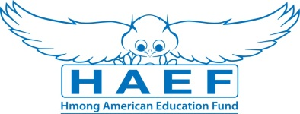
Nong Khai Scholarship Application
(Type responses below & email back to hmongeducationfund@gmail.com along with all other required documents in PDF)
Last Name: | First Name: |  | Middle:
Home Phone: | Cell Phone: |  | E-Mail:
Gender:  Female Male | Date of Birth (mm/dd/yyyy): |  | Race/Ethnicity:
Current Address:

City: | State: |  | Zip Code:
Permanent Address (if different from above):

City: | State: |  | Zip Code:
Check one of the following:  U.S Citizen  Legal Alien Resident of U.S.  None | Are you a first generation student?  Yes  No |  | Marital Status:  Single  Married  Divorced  Widowed
Number of parent(s): | Family size: |  | Number of dependents (if applicable):
Are you currently in high school or pursuing your GED?
Yes
No
Name of your current School: |  |  | Current GPA:
School Address:

Name of College/University you have been accepted to and/or will be attending:

Major/Program:

Degree you are seeking: Associate BA/BS Masters PhD/Doctorate Other:

What year of schooling are you in: First Year Sophomore Junior Senior

Will you be a Fulltime Student: Yes No
Have you been awarded other scholarships or financial assistance? (If yes, please list them):

Print Name: |  | Signature: |  | Date:
Disclaimer: By signing this application I understand that the information provided is true to the best of my knowledge. HAEF reserve the right to verify information submitted on the successful candidate’s application. In addition, the views and opinions expressed by individuals and/or businesses featured in our scholarships do not necessary represent the views of the Hmong American Education Fund.

