SIA YANG
IN LOVING MEMORY OF SIA YANG
APPLICATION PACKET
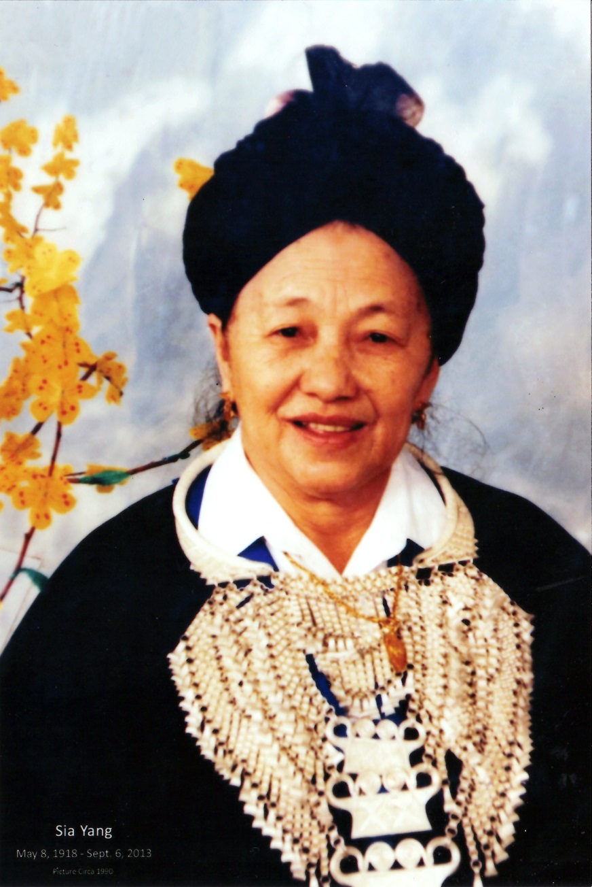
May 8, 1918 – September 6, 2013

PRESENTED BY
THE HMONG AMERICAN EDUCATION FUND
www.thehaef.org

This scholarship was donated by Lue Her & Xang Her in loving memory of Sia Yang

Sia Yang

Sia Yang was born to Cher Tong Yang and Yer Vue in the village of Xam Kaj in Laos on May 8, 1918 and passed on September 6, 2013 at the age of 95.

Sia had three sisters, Mao, Mai Yee, and Mai See and three brothers, Tou Vue, Chia Gao, Song Yer. In 1935, Sia married Ka Nao Her and together they had thirteen children, Tou Xue, Wakai, Bao, Yer, Mee, Boua Yang, Tou Bee, Chue Tou, Cher Xiong, Chai, Ka, Chee who passed away as a young girl, and an un-named infant who passed away shortly after birth. As a grandmother, Sia had a total of 285 grandchildren and great-grandchildren that extended across five generations.

Throughout her life, Sia witnessed significant geopolitical changes in the world through the lens of the Indochina and Vietnam wars. In almost a century of life, she lived through colonization, war, the persecution of her people, and the beginning of life in America. She was the matriarch that held her family together throughout turmoil and tragedy. Her life is remembered by her caring nature, love for family, and calm she exuded. Sia had a big heart for orphaned children. For many of her grandchildren, she served also as their mother. For this reason, a scholarship is established to provide assistance to students who have endured life without one or both parents.

Like so many grandmothers in Hmong society, Sia Yang played an important role in the rearing and caring of grandchildren. Without grandmothers like Sia Yang, whole generations of Hmong children would be at a lost especially during the war in Southeast Asia and the transition period here in the United States.

(Picture and biography provided by family.)

Instructions for the Sia Yang Scholarship
This scholarship is presented by the Hmong American Education Fund. The scholarship seeks to financially support one student in the pursuit of their educational goals. The successful applicant will be awarded up to $1,000 to the choice of their college or university. Download this application packet and fill out the form below. All application materials are due by April 15. Late applications and materials will not be considered. Any hand written application will be disqualified. All application materials must be emailed to hmongeducationfund@gmail.com. You will be notified of your application status via email by June 1.
Applicants Must Meet All Criteria Listed
- A U.S. citizen or legal resident alien
- Any state resident
- Any person of Hmong and/or Southeast Asian refugee student
- Any high school senior, high school or GED graduate or current college/graduate student is eligible
- Has been accepted fulltime to a 2-year or 4-year college/university or graduate school
- Lost parent/parents through death
Scholarship Application Packet, Checklist
- A completed application
- Essay (1500 words or less)
- Copy of unofficial transcript
- One letter of recommendation
- All required application documents should be sent in PDF format via email to hmongeducationfund@gmail.com
A Successful applicant must demonstrate the following
- Pursue an education to better themself and others
- A commitment to excellent academic achievement
- A commitment to helping your community
Essay: In one essay, 1500 words or less, please answer the following questions
- Tell us about your commitment to education
- Tell us how losing a parent or both parents have impacted you
- Tell us some of the things you have done to help your community outside of school
Additional Requirements
- If the recipient is from Minnesota, he/she is expected to attend the Scholarship Awards Banquet on the first Saturday of August.
- If selected, recipients are expected to submit the documents requested for the Scholarship Awards Banquet (ex. photo, bio, thank you letter to donors)
Successful applicants are encouraged to attend two general academic coaching and mentoring sessions with HAEF. These sessions can be done via phone, e-mail or face to face.
( If you have any questions, please email: scholarships@thehaef.org )

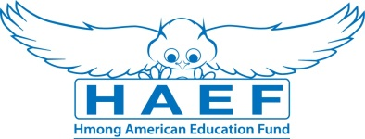
Sia Yang Scholarship Application
(Type responses below & email back to hmongeducationfund@gmail.com along with all other required documents in PDF)
Last Name: | First Name: |  | Middle:
Home Phone: | Cell Phone: |  | E-Mail:
Gender:  Female Male | Date of Birth (mm/dd/yyyy): |  | Race/Ethnicity:
Current Address:

City: | State: |  | Zip Code:
Permanent Address (if different from above):

City: | State: |  | Zip Code:
Check one of the following:  U.S Citizen  Legal Alien Resident of U.S.  None | Are you a first generation student?  Yes  No |  | Marital Status:  Single  Married  Divorced  Widowed
Number of parent(s): | Family size: |  | Number of dependents (if applicable):
Are you currently in high school or pursuing your GED?
Yes
No
Name of your current School: |  |  | Current GPA:
School Address:

Name of College/University you have been accepted to and/or will be attending:

Major/Program:

Degree you are seeking: Associate BA/BS Masters PhD/Doctorate Other:

What year of schooling are you in: First Year Sophomore Junior Senior

Will you be a Fulltime Student: Yes No
Have you been awarded other scholarships or financial assistance? (If yes, please list them):

Print Name: |  | Signature: |  | Date:
Disclaimer: By signing this application I understand that the information provided is true to the best of my knowledge. HAEF reserve the right to verify information submitted on the successful candidate’s application. In addition, the views and opinions expressed by individuals and/or businesses featured in our scholarships do not necessary represent the views of the Hmong American Education Fund.

